Individual Assignment Business Reporting Tools

Chinook Company

Assignment Description

As a CEO, you have to define a strategy and create an organization that will execute this strategy. Strategy starts with your vision and mission and then split them into sub-goals that will help you reach your targets. One tool to communicate and have people execute your strategy is using a strategy map (Kaplan & Norton 2000). So a strategy map quantifies the value of tangible and intangible assets and links them to your overall strategy.

Figure 1: Example of a strategy map.

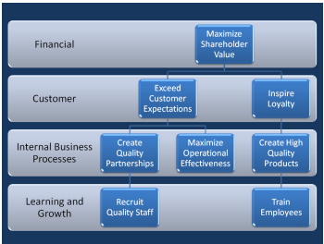

In this assignment, you are the new CEO of the Chinook company. You have decided that you will take a data-driven approach to strategy and first will analyze the company as is, to discover its strong and weak points. Then you will define a mission and a vision and break it down in a strategy map. Finally, you will create a balanced scorecard that enables management to track the performance of the company and how well it executes the CEOs strategy.

Required Output

The output required is twofold

* A Tableau that works correctly on a computer that does not have the dataset available. So when I open it, it has to function correctly. This means if you create a database, it has to be accessible for the teacher as well.
* Dashboards which allow to easily analyze the data on an individual level (eg, per track, album, genre, customer or employee: how do they perform?) This can be seen as a first step towards creating a strategy. No need to put this into a story.
* Think about a possible strategy and include your strategy map as a picture into tableau
* Balanced scorecard (another dashboard), representing the strategy and visualized in Tableau. (You can find an example at <https://public.tableau.com/profile/rudy#!/vizhome/scorecard_cleaned/ARAgingDashboard>). This scorecard looks more at an aggregate level. (eg over all customers, employees, managers, …).

Note: for the individual assignment, you do not have to focus on creating an SQL file. You can work in Tableau as much as you want. Of course, you can use it.

Data Description

The dataset is documented here : <http://www.sqlitetutorial.net/sqlite-sample-database/>. It was originally a SQLite database (an open-source RDBMS), but is already translated to SAS tables. You can find the ER scheme below (note that this is a different notation, typically used by Oracle databases as well, named Crow’s foot notation. The interpretation is fairly straightforward. You can find a description of the database below.

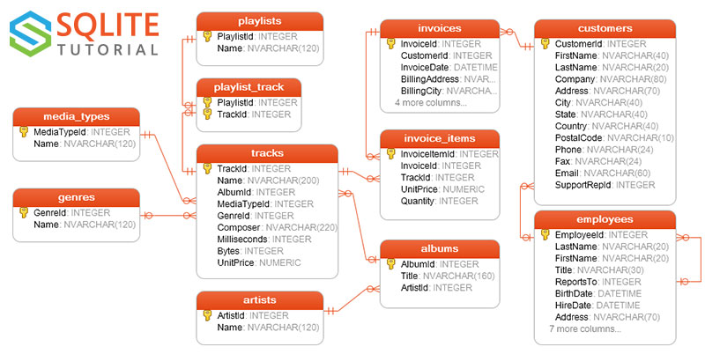

The notation is different from the typical ER-diagram notation of Chen. In this representation, entities are represented as relations, and the relations can be interpreted as follows:

* Between media types and tracks: A track can have one and only one media type (|| on the line) and a media type can be linked to zero, one or more tracks (circle with three stripes)
* Between genre and tracks: a genre can be linked to zero, one or more tracks, while each track is linked to zero or one genre (|0).

There are 11 tables in the chinook sample database.

* employees table stores employees data such as employee id, last name, first name, etc. It also has a field named ReportsTo to specify who reports to whom.
* customers table stores customers data.
* invoices & invoice_items tables: these two tables store invoice data. The invoices table stores invoice header data and the invoice_items table stores the invoice line items data.
* artists table stores artists data. It is a simple table that contains only artist id and name.
* albums table stores data about a list of tracks. Each album belongs to one artist. However, one artist may have multiple albums.
* media_types table stores media types such as MPEG audio file, ACC audio file, etc.
* genres table stores music types such as rock, jazz, metal, etc.
* tracks table store the data of songs. Each track belongs to one album.
* playlists & playlist_track tables: playlists table store data about playlists. Each playlist contains a list of tracks. Each track may belong to multiple playlists. The relationship between the playlists table and tracks table is many-to-many. The playlist_track table is used to reflect this relationship.